The Genealogical Connection between Peter Mandeyn, Blanchie and Crab Billy.

The Aboriginal Land Commissioner, Judge Peter Gray (2000: Para 2.18.1), describes ‘Peter Mandang’ as a ‘matrifiliate of the Danggalaba clan’. That is, someone whose mother was a member of the Danggalaba clan. The Kenbi Land Claim book (Brandl et al 1979:26) and Michael Walsh (1981) also include a chart of Danggalaba Clan descendants which lists Peter’s deceased mother as a Danggalaba member (see Appendix 5, Day 2010). Gray (Para 4.10.51) adds that ‘Peter Mandeyn’ had a Larrakia grandmother, the mother of his father, Jimmy Nalaga Galatimanau, said to have been known as Jimmy Larrakia.’ The Kenbi genealogies also indicate that Peter Mandeyn had at least one descendant, but the name is not recorded, and whatever descendants he may have had seem to have played no role in the various Larrakia land claims since 1979.

‘Peter Mundine’ @ Mandeyn/Mandang is also listed as a Larrakia language speaker on the genealogy prepared by Topsy Secretary in 1973. Peter was well-known in Darwin in the 1970s and participated in the Larrakia people’s land rights struggle (see photograph below). Topsy Secretary’s genealogy indicates that Peter’s Larrakia mother was the sister-in-law of Dedja Batcho’s mother (see Day 2010:47). That is, according to Topsy Secretary, Peter Mandeyn’s mother was the sister of Dedja’s father. Research for the Kenbi claim names Dedja’s mother as a Larrakia woman known as Blanchie. And according to Topsy Secretary, Blanchie’s husband was the brother of Peter Mandeyn’s mother. Whether this is correct or not, it does indicate that Topsy Secretary recognised a close genealogical connection between Peter Mandeyn and Dedja Batcho. Topsy would be in a position to confirm this, because both Peter Mandeyn and Dolly Gurinyi (Dedja’s sister) were alive in 1973 and often visited the Secretary family at Kulaluk.

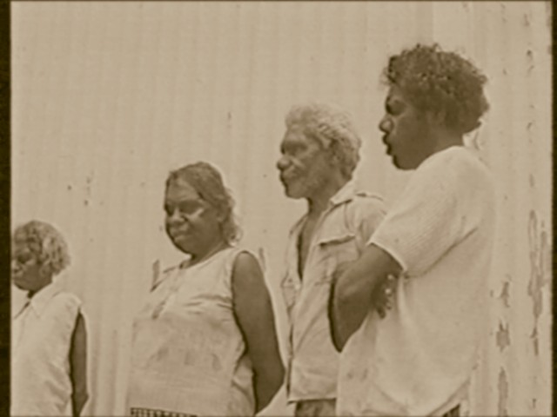
Above: Maggie Kwako, Violet Adams, Peter Mandeyn and Gabriel Secretary
protest outside Fannie Bay Gaol in 1972 (Source: ABC TV News).
The Danggalaba genealogy in the Kenbi Land Claim book (Brandl et al 1979:26; Walsh 1981; Day 2010:52) shows ‘Peter Munjang’ (‘Peter Mundine’ on Topsy’s genealogy) as the son of an unnamed Danggalaba woman who was the putative (adopted or classificatory) sister of Crab Billy. This family connection between Peter Mandeyn and Crab Billy is shown by a dotted line in the Kenbi genealogy and explained in the Legend (Key) as a ‘putative or adoption’ link. It therefore appears that according to this genealogy, Peter’s mother was a sister of the four classificatory brothers of the Danggalaba clan – Crab Billy, Frank Secretary, King George and Tommy Lyons. Topsy Secretary’s genealogy also shows this link but has Peter’s mother as a sister-in-law of the four classificatory brothers, with Dedja’s mother Blanchie as the sister.

The Kenbi Danggalaba genealogy (Brandl et al 1979:26) also shows a Danggalaba man named Long Mac as the brother of Crab Billy with the same father (see illustration below). Brandl and Walsh therefore list both Long Mack and Crab Billy as putative brothers of Peter Mandeyn’s mother. It is unlikely that either Long Mack or Crab Billy (the brothers of Peter’s mother on the Kenbi charts) were the spouse of Blanchie and the father of Dedja; however, they could be classed as fathers in Larrakia custom.

In summary, according to Brandl et al (1979:26) and Walsh (1981) the mother of Peter Munjang (Mandeyn) was definitely a member of the Danggalaba clan. The Kenbi Danggalaba genealogy (Brandl et al 1979:26; Walsh 1981) also suggests that Peter Mundine’s mother and Crab Billy were classificatory, adoptive or putative siblings, while Topsy Secretary’s genealogy suggests Blanchie had an affiliative connection (by marriage) to Peter Mandeyn’s mother. However, which ever is correct, Peter’s mother would still be ‘sister’ to Crab Billy, Frank Secretary, King George and Tommy Lyons, while Topsy Secretary’s 1973 genealogy also shows Blanchie as a sister to Crab Billy and the four Danggalaba brothers.

Extrapolating from the genealogies, if Crab Billy was Dedja’s ‘uncle-father’, he would be Yula Williams’s grandfather. Combining the two genealogies suggests such a link. Similarly, a close genealogical connection between Dedja Batcho and Crab Billy is independently suggested in the biographical notes for Crab Billy recorded by Robert Graham (1997:30). In Robert Graham’s report, Yula Williams is quoted as saying, ‘I call him [Crab Billy], like son. Nayi, our way that means son. Crab Billy was living at Bagot ... He died during the War I think... I called him son. Nayi or nimp. He used to come to our place, and they used to speak to Mum. She said, ‘that’s all our people.’ The above evidence may be useful in situating Dedja Batcho and her descendants in the Danggalaba clan and confirming the structure of Topsy Secretary’s version of the Danggalaba clan genealogy.
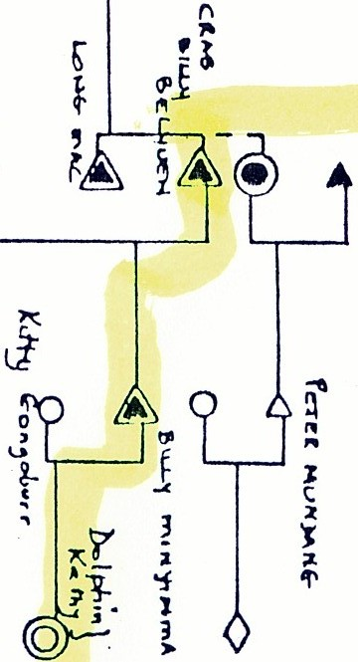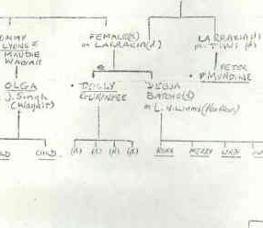
Above (left): Peter Munjang on the Kenbi Danggalaba 1979 genealogy (Appendix 5, Day 2010).
Right: Peter Mundine as shown on Topsy Secretary’s 1973 genealogical chart.

William B Day
Perth, WA, 2010
*******************************************************************************
References
Brandl, M, A Haritos and M Walsh 1979 Kenbi land claim to vacant Crown land in the Cox Peninsula, Bynoe Harbour and Port Patterson areas of the Northern Territory of Australia. Darwin: Northern Land Council
Day, W B 2010 A Report on a Native Title Claim by Kevin Lance (Tibby) Quall on behalf of the Danggalaba Clan. Unpublished report, Darwin, NT.
Graham, R 1997 Kenbi (Cox Peninsula) Land Claim: Submission on behalf of some members of the Danggalaba. Darwin: Northern Land Council.
Gray, P R A 2000 The Kenbi (Cox Peninsula) Land claim No. 37: Report and recommendations by the Aboriginal Land Commissioner, Justice Gray, to the Minister for Aboriginal and Torres Strait Islander Affairs and to the Administrator of the Northern Territory. Canberra: Australian Government Publishing Service.
Walsh, M 1981 Report on sites of significance in the Larrakeyah Barracks – Emery Point area, Darwin. Darwin: Aboriginal Sacred Sites Protection Authority.

See also Day (2010: Appendix 5). Brandl et al list six people ‘whose mothers are or were members of the danggalaba clan’. They are, Linda Roman, Kathleen Secretary, Raelene Singh, Jason Singh, Zoe Singh and Peter Mandang.
Also known as ‘Peter Monday’. The 1957 Government Gazette record of Aboriginal Wards lists ‘Peter Mandein, Larakia, born 1927’.
Statement based on first hand personal knowledge.

